HOPE worldwide Japan Report 2013

- HOPE’s Continual Support for the disaster area
This is the second year of our HOPE programs in Watari town. This town was severely affected by the mega earthquake and Tsunami in 2011. About 270 residents lost lives and 30% of the houses and buildings were destroyed. Even after 3 years since the earthquake, many residents are unable to return home and are still living in temporary housing. It is fortunate that with the help of our donors, HOPE worldwide Japan is able to continue our programs to support those who were affected by the great disaster.

1) HOPE Therapy Program (Beneficiaries in 2013: 2,628)
In 2013, we offered a number of therapy classes using flowers and vegetables. About 350 people regularly participated the floral classes, and 22 people grew vegetables and harvested crops. In total, 2,628 people in the area benefitted from HOPE’s therapy program.

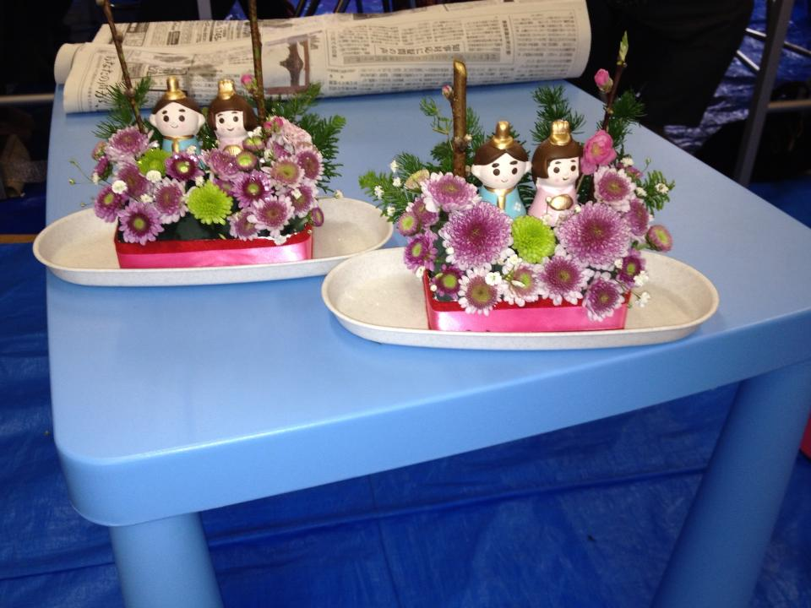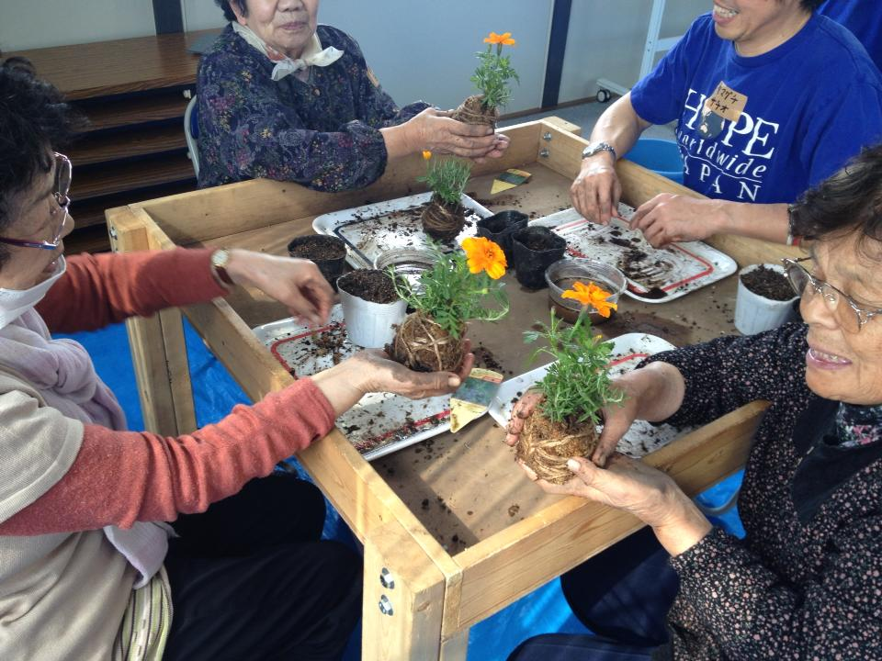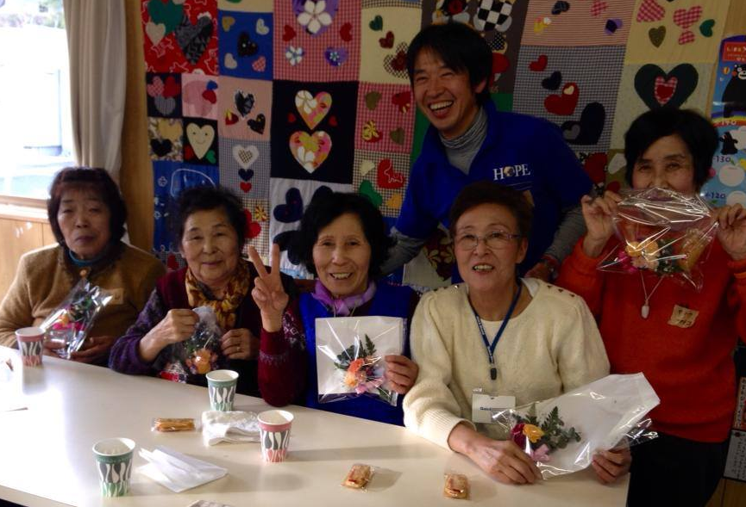
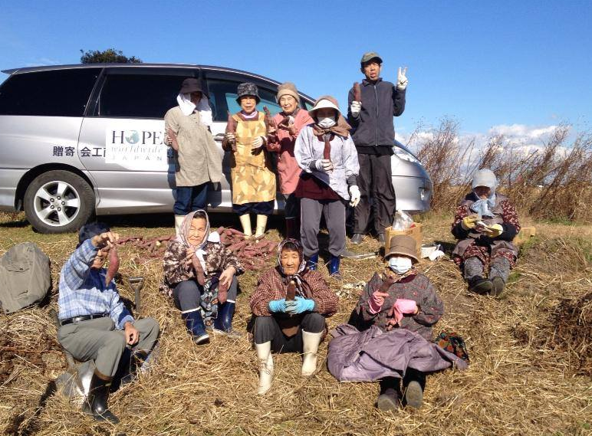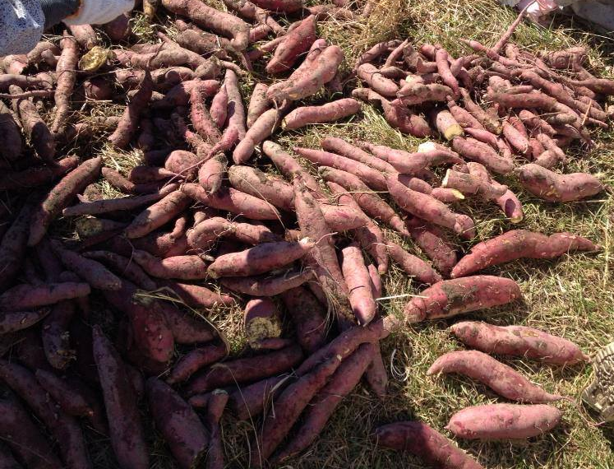

<<HOPE Therapy Garden>>
Since HOPE Therapy Garden was opened in 2012, we have visitors in a consistent basis from the neighborhood area and out of town. Our vision for the garden is that it would become like an oasis for people who visit where they relax and be comforted by the beauty of nature.

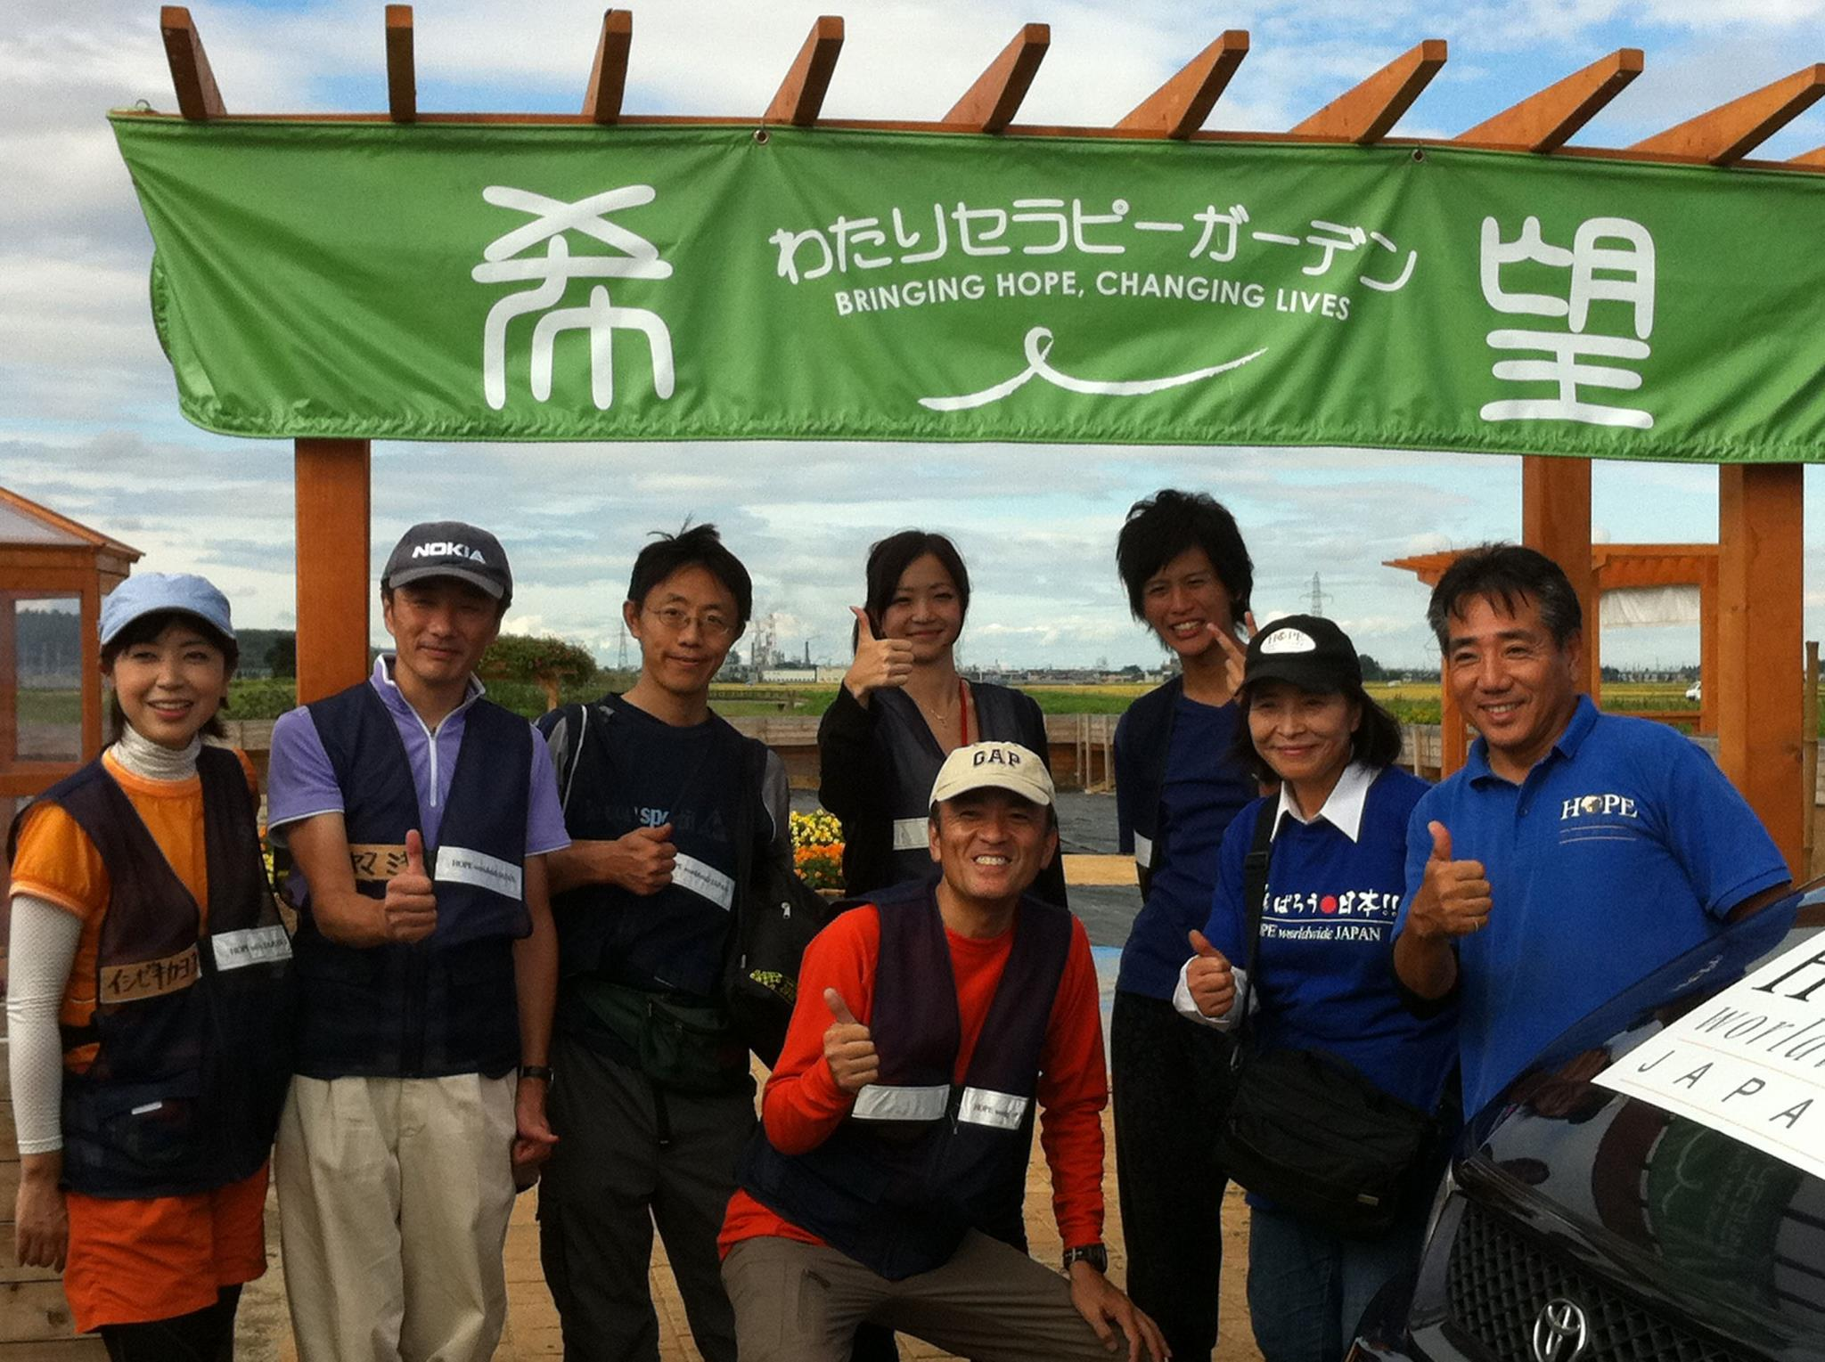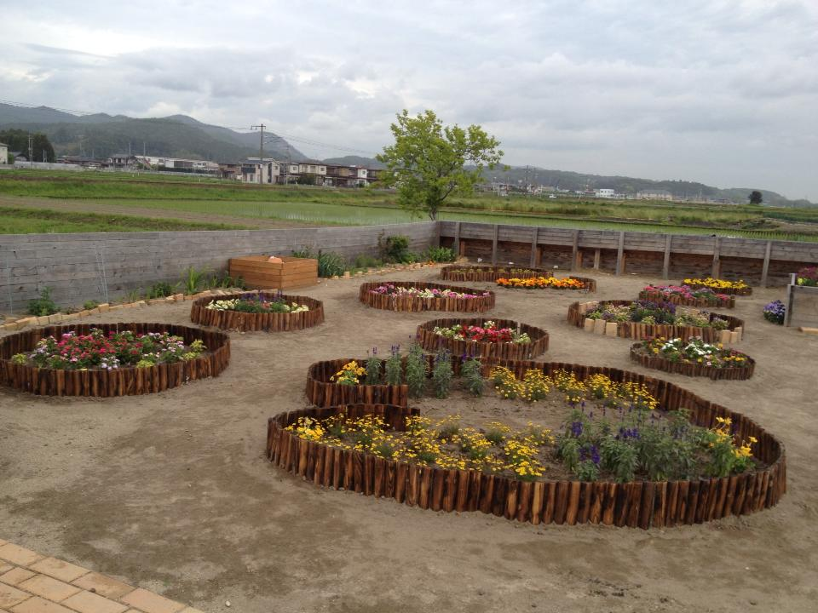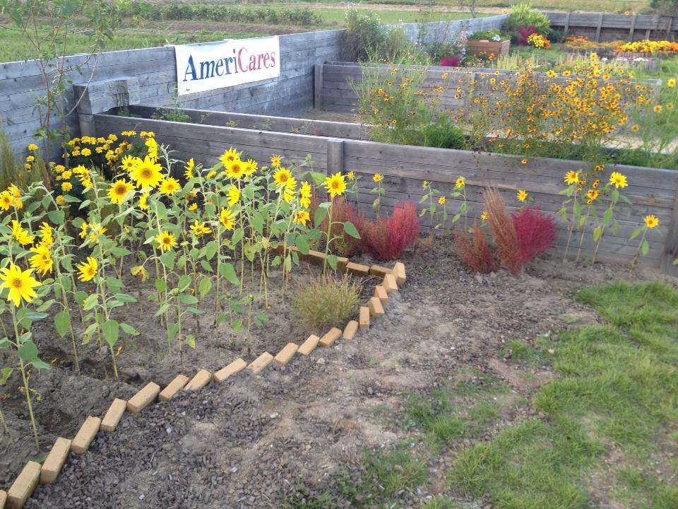
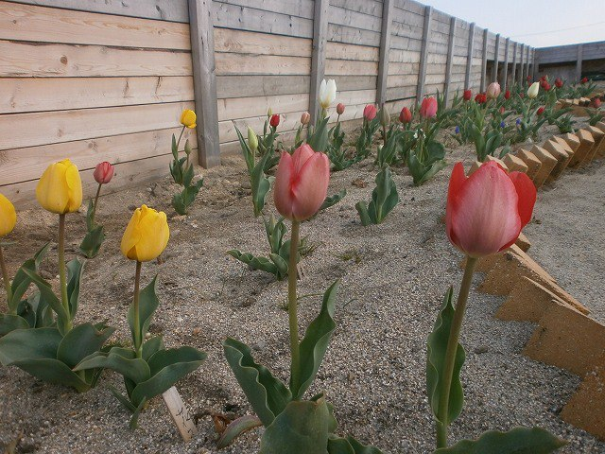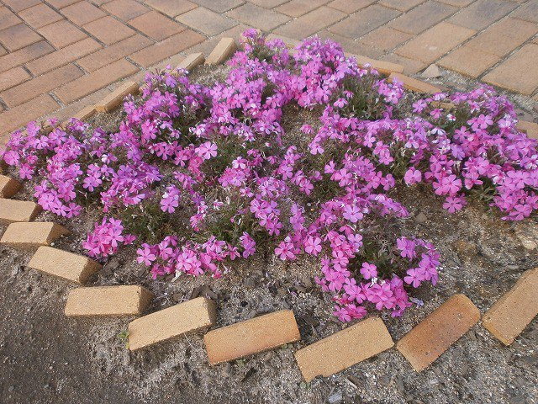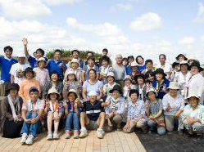

- Meeting Place for Locals
HOPE Therapy Garden is becoming a place for local people to meet. A number of people, young and old, visit our garden everyday. Our regular comer says, “This is the most favorite thing for me to do every morning, just to rest and watch those beautiful flowers in this garden.” Some of our visitors even support us by cleaning or watering our garden. It is great to see how our garden is becoming a part of this community, and a circle of friendship starts from here. This is our vision for the garden, and we are fascinated to see our dream coming true.

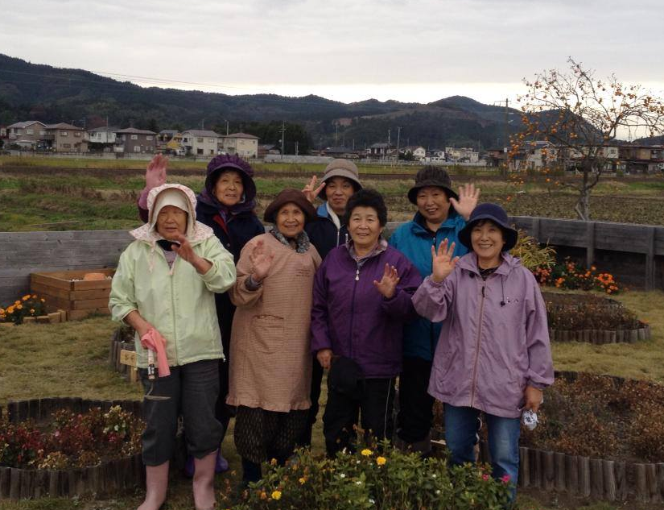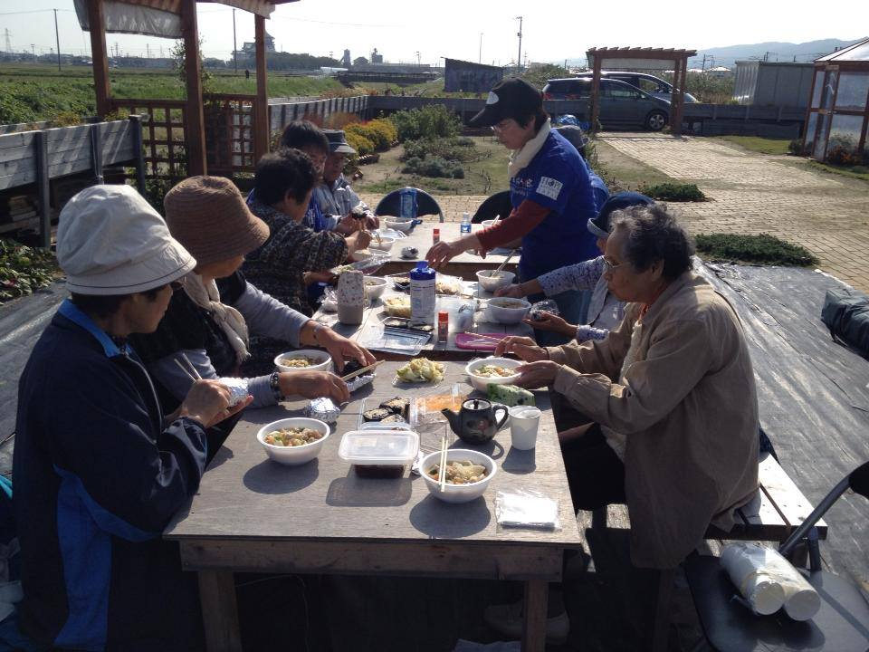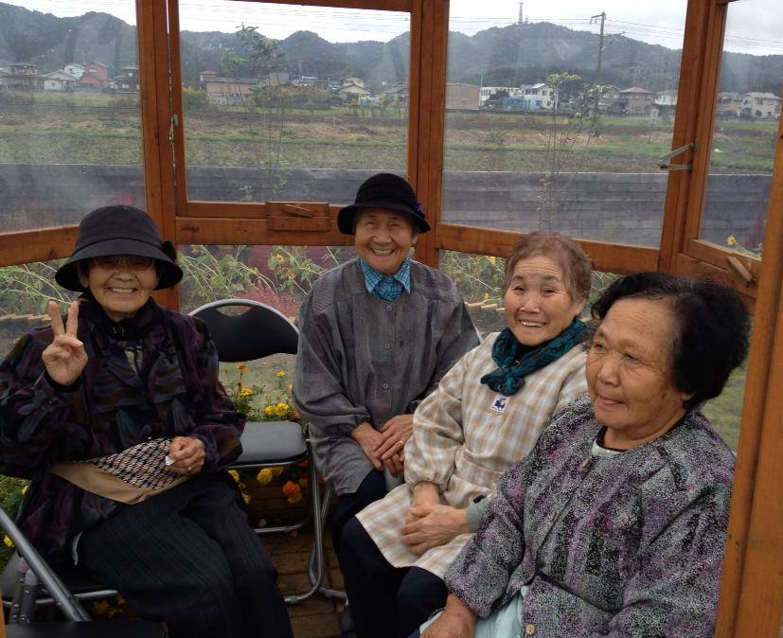

- Playground for Children
Everyday, we have small visitors from a local kindergarten. The kindergarten set their walking path through our garden, hoping that children would cultivate a caring and loving heart for life and sensitivity to other creatures. It is fun to see children aged from 1 to 6 years running around the garden and asking a lot of questions in curiosity. Some of them show strong interests in plants and do research with botanical books.
This coming fall, HOPE is planning together with the kindergarten to hold special activities and learning opportunities for children.

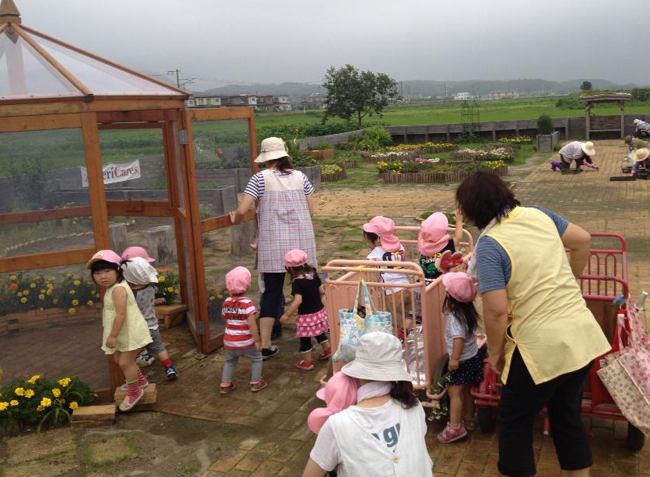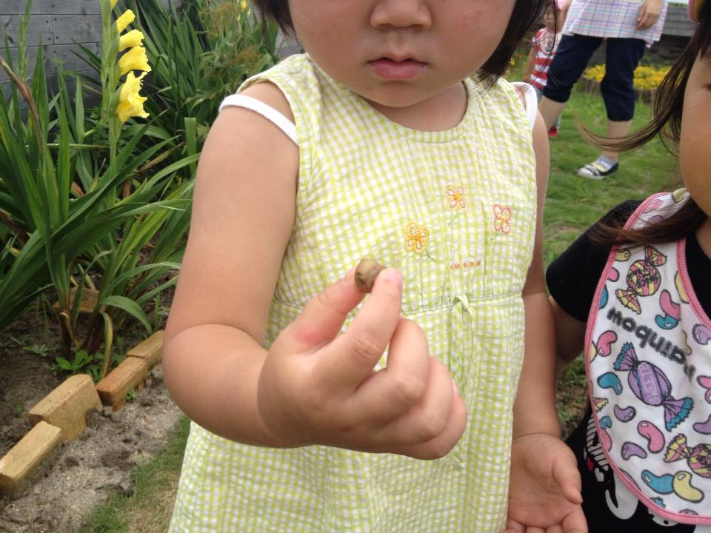
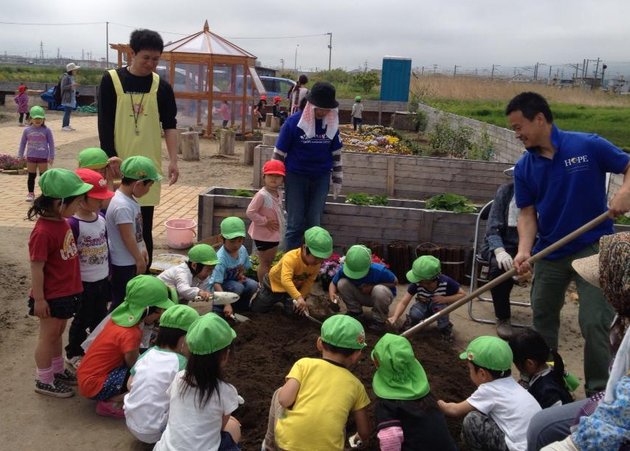

- Male Participants Needed!
We have a number of female participants regularly. On the other hand, finding male participants can be challenging. We came up with a furniture building project to attract men in the area. And for the first time, we had a large group of men participating! They worked together in a team building benches and tables for our garden. As they helped each other to accomplish one task, they also started building new relationships. Some of them visit our therapy garden regularly now.

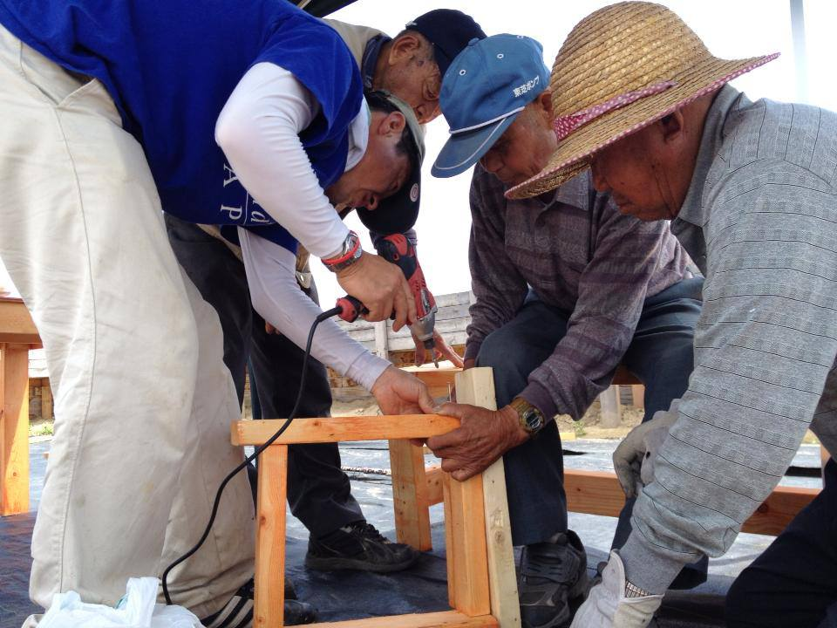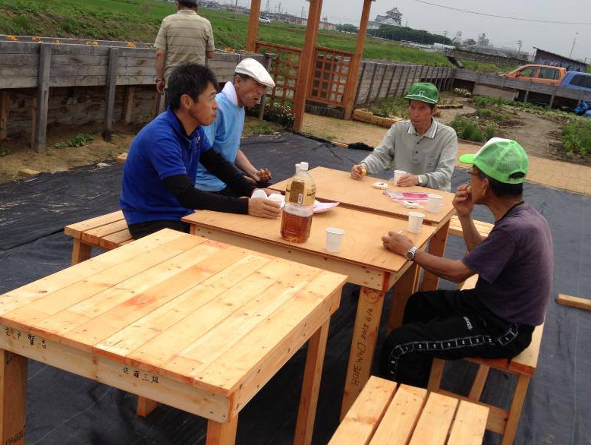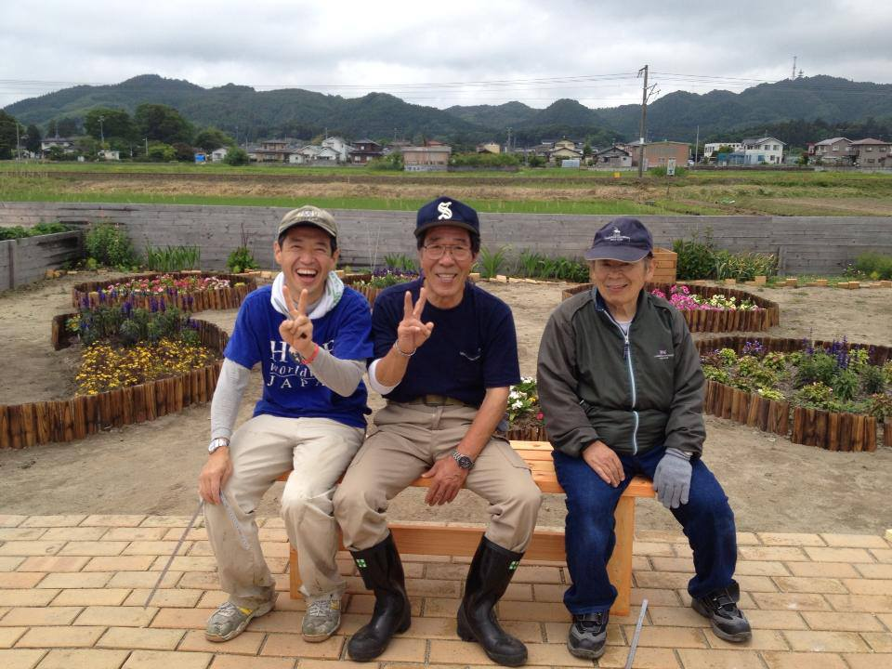

- Rooted in the Community
Our biggest challenge with the garden is fast growing weeds! Sometimes our neighbors help us to pull up weeds, but we are surprised how quickly our garden is covered in weeds again. Most of the residents in this area are farmers who are actually experts on dealing with weeds, so we have asked them for help and support.
Now people come to help us on a weekly basis saying, “You have given to us so much. We are glad that now we are able to give it back to you a little.” With their support, we have been able to maintain the beautiful garden. We are encouraged to see how willingly people in this community are involved in our program and how our garden is becoming an essential part of this community. It is our vision for the garden: being loved and taken care of by locals in this community.

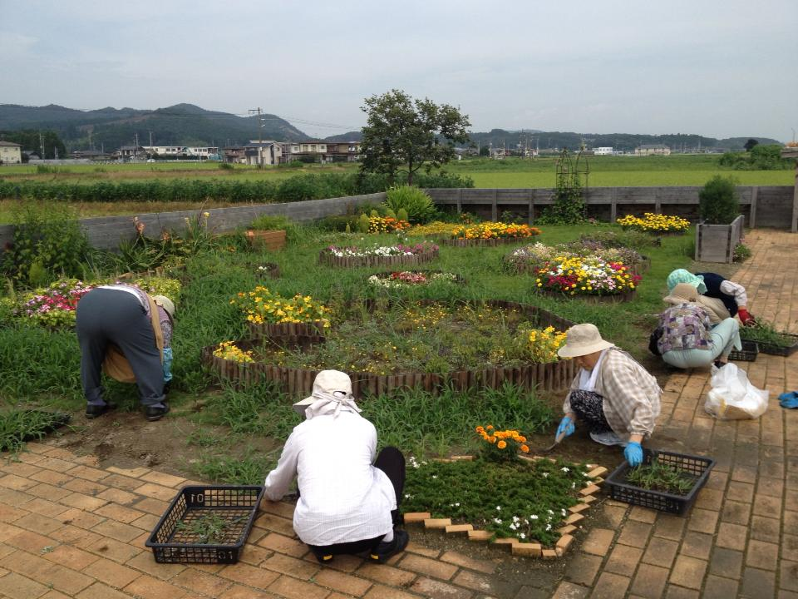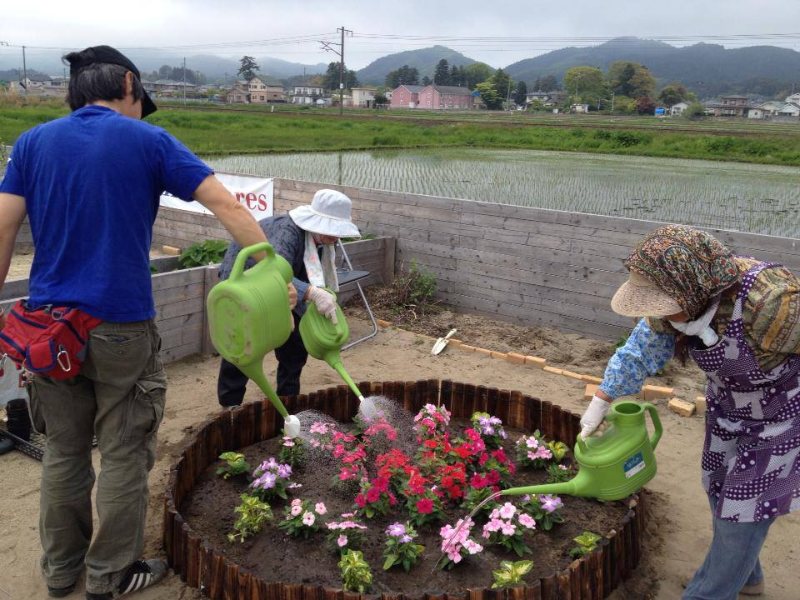

-------

2) HOPE Job Assistance Program (Number of beneficiaries in 2013: 14)

On June of 2013, we started the brand new program for earthquake victims and people with disabilities. Our goal is to meet the needs of people in this area by offering work training and experience.

<<HOPE Distribution Outlet “Ichigo-Ichie” >>
We opened a store called “Ichigo-Ichie” that sells baked goods and vegetables. Fresh vegetables are delivered everyday from farmers nearby. The opening of our store was reported by one of the major news papers in Tohoku area. And the mayor also sent us the message expressing his appreciation to HOPE and our contribution to the community.

- Our Customers
Since the opening, we have various kinds of customers: students, children, elderly with a grandchild, etc. Some customers purchase our baked goods for a work meeting or coffee time, and some people come with their family members with disabilities. We are greatly encouraged by the support from our neighbors and how they welcomed us into this community.

- Our Employees
We started with two employees and now have 14 people working with us. Most of our employees have disabilities and were out of work for many long years. They are extremely grateful for the working opportunities at Ichigo-Ichie. At first, they were nervous about the new working experience, but they enjoy working now and greet customers with a big smile!

- Our Vision
Our facility can hold up to 20 employees. We are hoping to train new people who have disabilities and earthquake victims who live in temporary housing. Working with the community, we are looking forward to supporting more people to reintegrate into society.

